Trigonometry

Name
Institution
Course
Date

Number two
Using $\cos{∅}$ =$\frac{adjacent line}{hypotenuse }$
$$\cos{60=\frac{8}{x}}$$
X $\cos{60=8}$
Therefore, x = $\frac{8}{\cos{60}}$
X = $\frac{8}{0.5}$
= 16
Number three
Using $\tan{∅}$ = $\frac{opposite }{adjacent }$
$\tan{30}$ = $\frac{x }{12 }$
X = 12 $×\tan{30}$
= 12 × 0.5774
= 6.6929
Number four
Using $\cos{∅}$ =$\frac{adjacent line}{hypotenuse }$
$$\cos{49=\frac{x}{27}}$$
Therefore,
X = 27 × $\cos{49}$
X = 0.6561 × 27
= 17.7147
Number five
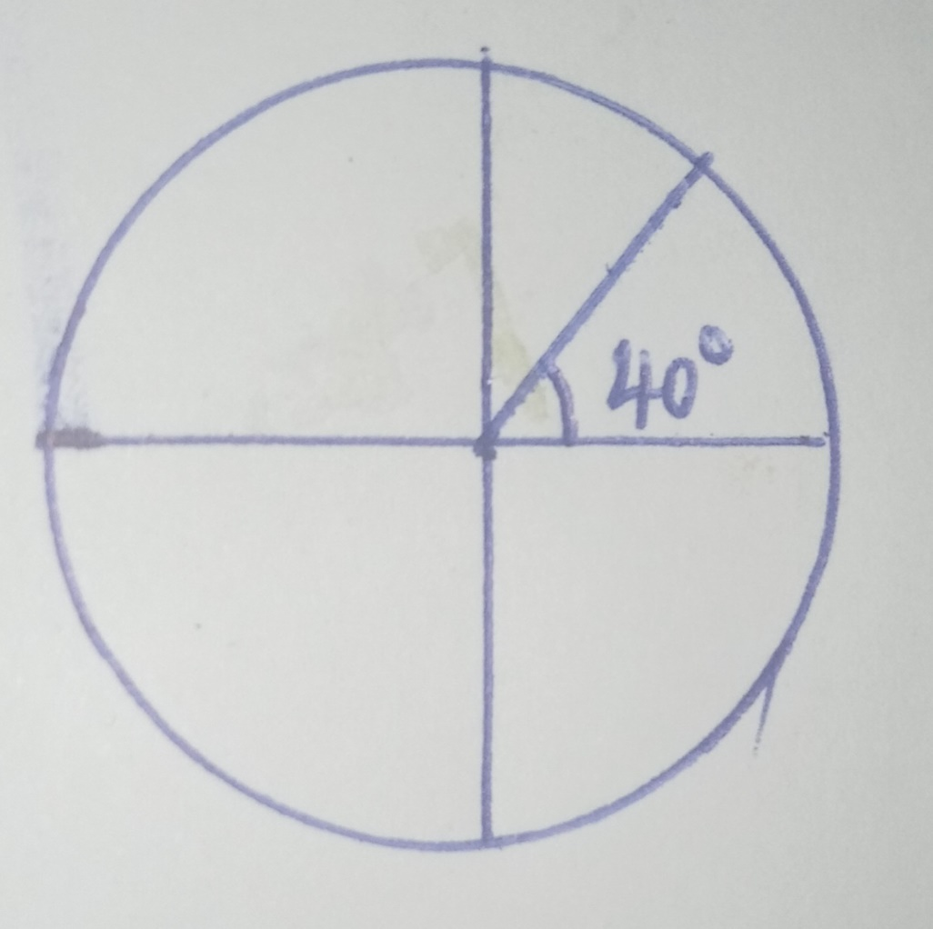
The positive coterminal angle is 40⁰ + 360⁰ = 400⁰
The negative coterminal angle is 40⁰ – 360⁰ = 320⁰
Number six
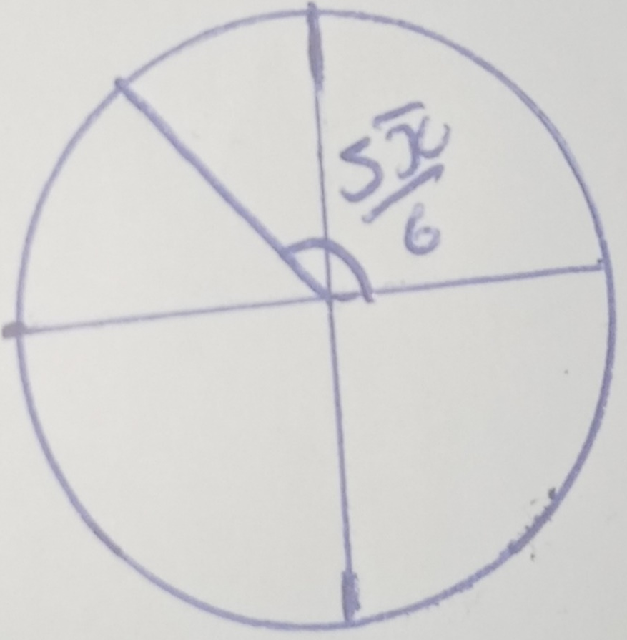
the positive coterminal is $\frac{5π}{6}+2π$ = $\frac{19π}{6}$
The negative coterminal is $\frac{5π}{6}-2π$ = $\frac{7π}{6}$
Number seven

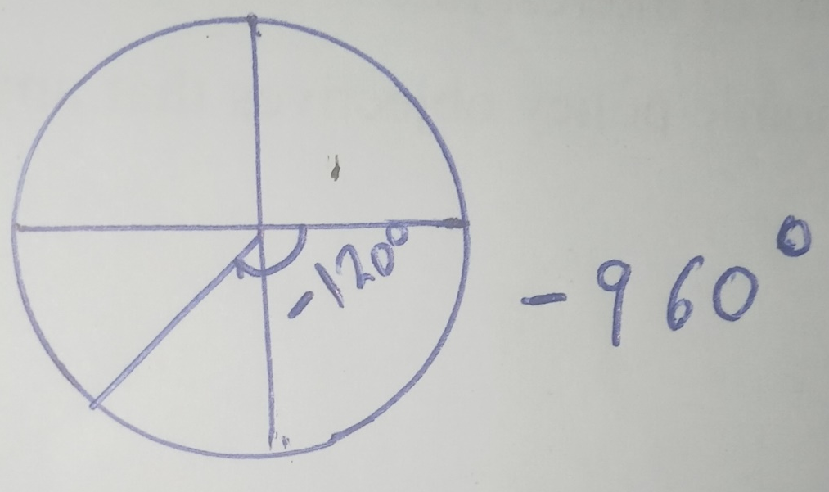
The positive coterminal is – 960⁰ + 360⁰ = - 600⁰
The negative coterminal is – 960⁰ - 360⁰ = 1320⁰
Converting degrees to radians and radians to degrees
Number eight
$$\frac{3π}{10}$$
1 π radian = 180⁰
= $\frac{3}{10}$ × 180⁰
= 54⁰
Number nine
-60⁰
1 π radian = 180⁰
Therefore, -60⁰ =?
= $\frac{-{60}^{0}}{{180}^{0}}$
= $\frac{π}{3}$ radians

Number 10
72⁰
1 π radian = 180⁰
Therefore, 72⁰ = $\frac{72}{180}$
=$\frac{2}{5}$
Number 11
We first calculate the angle $∅$ as shown below
Tan $∅= \frac{opposite }{adjacent }$
Opposite = 2 and adjacent = 6
Tan $∅$ = $\frac{2}{6}$
$$∅= \tan^{-1}{0.3333}$$
= 18.42
We are looking for the trigonometric functions of 251.58⁰
Therefore, it is in the third quadrant so only tan and cot are positive
Tan 251.58 = 0.3333
Cot 251.58 = $\frac{1}{\tan{251.58}}$
=$\frac{1}{0.3333}$
= 3.00
Sin 251.58 = - $\sin{18.42}$
= 0.3160
Cosec 251.48 = $\frac{1}{0.3160}$
= 3.1646
Cos 251.48 = $\cos{18.42}$
= 0.9488
Sec 251.48 = $\frac{1}{0.9488}$
= 1. 0540
Number 12
$$∅=\frac{π}{2}$$
= 90
The angle $∅$lies on the first quadrant so all ratios are positive
Sin 90 = `1
Cos 90 = 0
Tan 90 = 1.6331
Cot 90 = $\frac{1}{\tan{90}}$
= $\frac{1}{1.6331}$
= 0.6123
Sec 90 = $\frac{1}{\cos{90}}$
=$\frac{1}{0}$
= infinite
Cosec 90 =$\frac{1}{\sin{90}}$
=$\frac{1}{1}$
= 1
Number 13
$$∅=\frac{2π}{3}$$
= $\frac{2}{3}×180$
= 120⁰
The angle lie in the second quadrant thus only sine and cosec are positive
Sin (180-120)
Sin (120) = Sin (180-120)
Sin (60) = 0.8660
Cosec = $\frac{1}{0.8660}$
= 1.1547
Tan 120 = -tan 60
= - 1.7321
Cot 120 = $- \frac{1}{1.7321}$
= 0 5773
Cos 120 = - Cos 60
= - 0.5
Sec 120 = $- \frac{1}{0.5}$
= -2
Number 14
Identifying the amplitude and period
g(x) = 3 sin x
Amplitude is the slope of the function
= 3
Period is the distance between two consecutive highest points
= 360⁰

Graph of the function is shown below
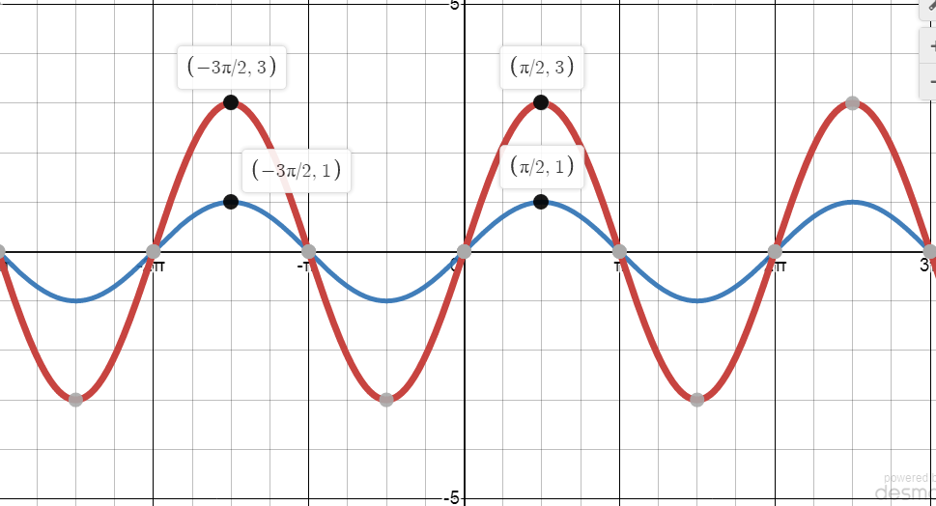

The graph f(x) transforms to g(x) such that the amplitude is tripled but the period remains.

